* **Lab Task 3:**

### Determine the Number of International Flights

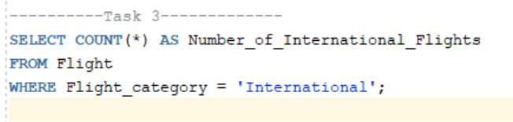

Output:

